Multiposition Valve Chemstation Integration Software
Application Note
Technical

Authors
Manfred Lenz
Agilent Technologies Sales & Services GmbH & Co. KG
Pappelweg 16;Straubenhardt, BW 75334;GERMANY
Manfred_Lenz@agilent.com

Jiri Zima
Agilent Technologies R&D and Marketing GmbH & Co. KG
Hewlett-Packard-Strasse 8;Waldbronn, BW 76337;GERMANY
Phone: +49 (0)7243 608 311 Fax: +49 (0)7243 602 666
Jiri_Zima@agilent.com

Abstract
Multiposition Microelectric Valve Actuator (VA) was integrated with Multitechnique Chemstation G2070BA B.04.03 [52]. The VA is controlled via serial communication from the Workstation and is independent of the Gas Chromatograph.

The stream is defined for single run in Sample info as Location or for multiple runs in Sequence table Vial column.

Description
There are 2 files implementing the functionality. MultiPositioningValve.exe and MultiPositioningValve.mac¹. The installation represents simple copy of MultiPositioningValve.exe file into instrument subdirectory (e.g. Chem32\1 folder) and MultiPositioningValve.mac into Chem32\Core directory. The utility (UT) requires Microsoft .NET FW 2.0 or higher. This should be downloaded from Microsoft prior to installation with respect to the operating system of the Workstation.

¹ For 16-bit Chemstation the macro name needs to be shortened to, e.g. MPV.mac. The Runtime Checklist needs changing the Pre-Run Command/Macro to macro “MPV.mac”, go (see below).

The link between Chemstation Method and the UT is entered into Run Time Checklist as shown below:
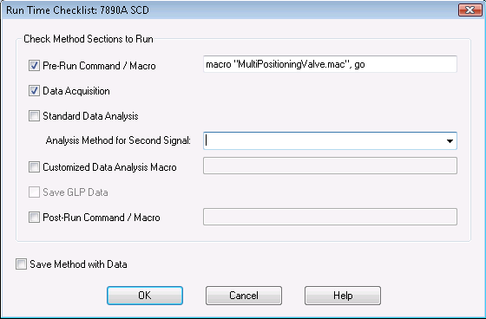

This way the UT is only active for a particular method.

VA has to be connected to a Workstation COM port or USB to COM adapter.
Only RS232 protocol is supported.
The communication port configuration is done by running the MultiPositioningValve.exe program from within the instrument subdirectory (it has to be started in the folder as it creates MPV.INI file where communication and other parameters are stored). For each of the four Chemstation instruments up to four VAs can be controlled if multiple COM ports are available.

This is how UT example UI looks like:
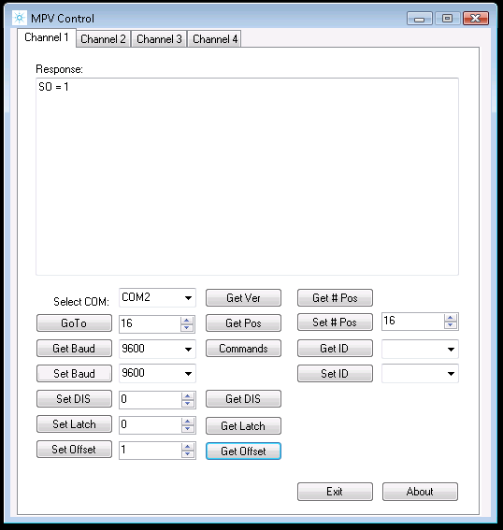

The COM port, Baud Rate and ID needs to be set properly to be able to communicate.

Do not change any parameters unless you understand what you are doing!
Read the included TN from VICI first.

Tooltip help is provided for all objects of the dialog widow. Move your mouse cursor on top of an object and wait for the Tooltip to appear.

Once the configuration and functional test is finished make sure to close the application by clicking [Exit] button. It will save information for all four channels and that information will be used by Chemstation.

The UT is also writing information about requested and actual stream position into the sequence logbook.

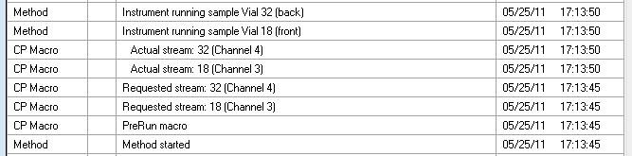

Lines with problems selecting the stream position will indicate error (e.g. in case position higher or lower than permitted is asked for).

Additionally, the UT will also create MPV.LOG in the instrument folder, e.g. C:\Chem32\1. That keeps track of all valve related actions with a time stamp, COM and ID.
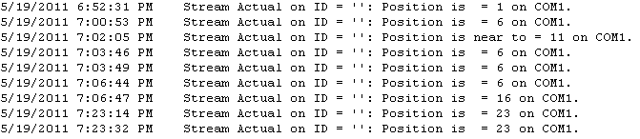

The VA is able to have identification number assigned (e.g. ID = 0) or no ID can be used.
The VA comes with no ID assigned from the manufacturer.
To change ID retrieve first the current ID from the VA by [Get ID]. Then select the required ID (space, or 0 to 9) and click [Set ID] button.
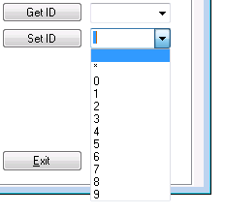
If the VA has an ID and it needs to be cleared, it can be done by selecting * and clicking [Set ID] button.
When the UT is exited and ID is left at *, the UT will send command to all VAs having ID assigned.
This is not supported if multiple VA are connected to one COM port.
Controlling multiple VAs connected to one COM port is possible as long as each VA is having unique ID and multiple channels are specified (e.g. Channel 1 uses COM1 and ID=1, Channel 2 uses COM1 and ID=2).

Mapping streams
By default the expected number of positions per actuator is 16.
By remapping to 4 actuators a range 1 to 64 is possible.

GC Chemstation can run in 3 modes: Front, Back and Dual.
Entering Location in sample info or Vial into sequence defines the stream to be selected.
If injection source is GC Valve, maximum Vial/Location is 32.
Manual injection source allows for 0 to 999 but 0 is not a valid stream for VA.

If Front only is used then 1-16 is sent to VA1, 17-32 to VA2, 33-48 to VA3 and 49-64 to VA4.
VA#: 1 2 3 4
VA:
Vial/Location: F1-16 F17-32 F33-48 F49-64
Offset: 1 17 33 49

If Back only is used then 1-16 is sent to VA1, 17-32 to VA2, 33-48 to VA3 and 49-64 to VA4.
VA#: 1 2 3 4
VA:
Vial/Location: B1-16 B17-32 B33-48 B49-64
Offset: 1 17 33 49

If Dual is used, front channel 1-16 is sent to VA1 while 17-32 is sent to VA3.
Back channel 1-16 is sent to VA2 while 17-32 is sent to VA4.
VA#: 1 2 3 4
VA:
Vial/Location: F1-16 B1-16 F17-32 B17-32
Offset: 1 1 17 17

When 16-position VAs are used, the offset needs to be changed for higher than 16 streams.
For example, if the VA is expected to process 17-32 positions, the offset must be set to 17 and so on.
Offset is changed by dialing the number in the entry field between buttons [Set Offset] and [Get Offset] and executing [Set Offset].
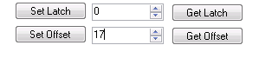

Troubleshooting
If Stream = 0 appears in the Chemstation logbook or any other problems, check the settings and operation manually (by starting the MultiPositioningValve.exe) or view MPV.LOG file.

Information about authors, features, setup and limitations are available under [About] button.

For more details about the actuator see the TN 415.

References
VICI Valco Instruments Co. Inc. Technical Note 415
www.vici.com/support/tn/tn415.pdf

Windows and .NET FW is a trademark of Microsoft Corporation.
VICI is Valco Instruments Co. Inc.

www.agilent.com/chem

Agilent shall not be liable for errors contained herein or
for incidental or consequential damages in connection
with the furnishing, performance, or use of this material.
Information, descriptions, and specifications in this
publication are subject to change without notice.
© Agilent Technologies, Inc., 2011
Printed in Germany
May 26, 2011
????-????EN

